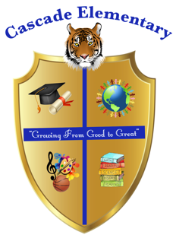

Cascade Elementary Website
Weekly Grade Level News Blast

Week of: Monday, April 20, 2020

Grade Level: 1st Grade

Standards of the Week:
Reading: ELAGSE1RL1 Ask and answer questions about key details in a text.
ELAGSE1RL2 Retell stories, including key details, and demonstrate understanding of their central message or lesson.
ELAGSE1RL3 Describe characters, settings, and major events in a story, using key details

Math: MGSE1.MD.4 Organize, represent, and interpret data with up to three categories; ask and answer questions about the total number of data points, how many in each category, and how many more or less are in one category than in another.

Science: S1P2. Obtain, evaluate, and communicate information to demonstrate the effects of magnets on other magnets and other objects.

Social Studies: SS1H1 Read about and describe the life of historical figures in American history.

Additional Information for Parents and Students:

- We will continue having our Virtual Daily Meetings at 10:00 am. We will continue using the app Zoom which is located in mybackpack. All students are required to attend each day as we will be taking daily participation points. This will allow the students the opportunity to ask questions about any assignments or any concerns. Your child’s teacher will be reaching out to you with more information.
- Continue using google classroom to complete all daily assignments. If you have any questions please reach out to your child’s teacher.

Evelyn.hooks@atlanta.k12.ga.us
Josby@atlanta.k12.ga.us
Erin.pratt@atlanta.k12.ga.us

